Special Shows

Introduction to astronomy (60 minutes)

This presentation was designed to help the Guides and Scouts earn their merit badge in astronomy.

It's a first step into the world of stars. Discover how to "star hop ", find constellations, tell time using the stars and build and use your own star clock. Take an imaginary trip through our solar system and see the planets close up.

Legends of the Night Sky: (50 minutes)

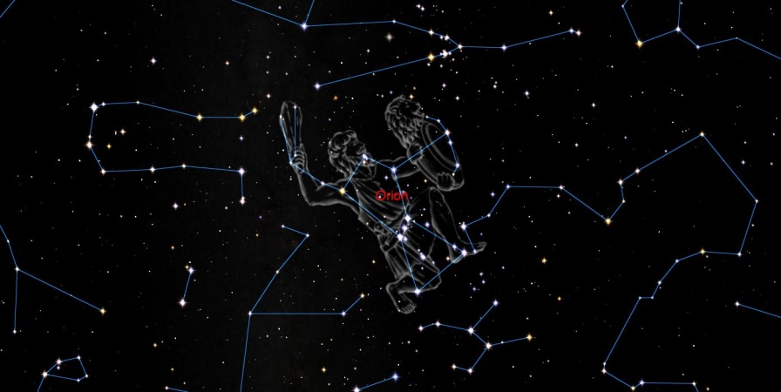
The skies retell the stories of ancient’s heroes, princesses and monsters. Greek and Romans legends fill the night sky. Not as well-known Native American legends are part of North America’s folklore. Let use bring these legends back to life under our starry skies.

Ride along with a comet (45 minutes)
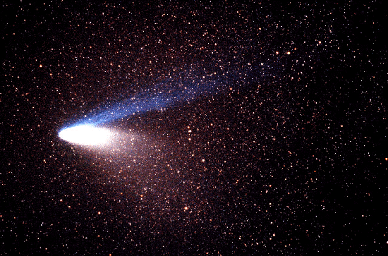
(Ages 5 – 9)

A starry sky hides two bears, a lion, a flying horse, a princess and numerous surprises. A Native American legend tells us how the constellations came to be. Just like the Little Prince travel with a comet as it travels through the solar system. One by one the planets reveal their marvellous, mysterious and unique secret.

