Presentations

The Sky Tonight
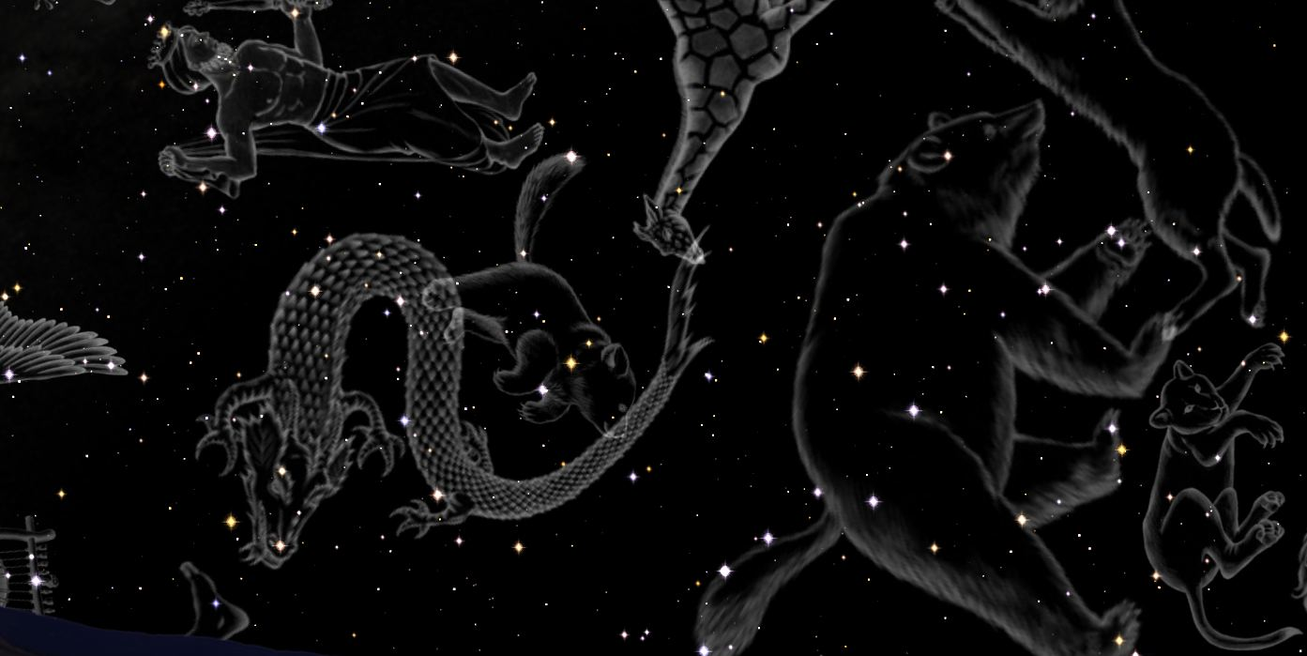

All our planetarium presentations start the same way, with the evening sky on the night of your visit. As the Earth rotates, the planetarium projector displays the changing parade of constellations and deep sky objects (nebulae, galaxies, neutron stars, black holes, protostars and dying stars). At sunrise the projector simulates twilight and our star, the sun. We watch it arc its way across the southern sky as our narrator describes its fiery beauty. Once the sun sets, we take an imaginary trip as the Earth revolves around the sun, and note the changing view of the sky as seasons roll by. The format of this presentation varies, depending on the age group visiting us. (“A” 30 minutes, “B” 30 minutes, “C” 60 minutes).
For last part of the presentation, choose any one of the following topics.

Touring the night sky (30 minutes)
(Grades 1 through 3)

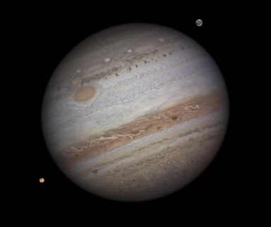
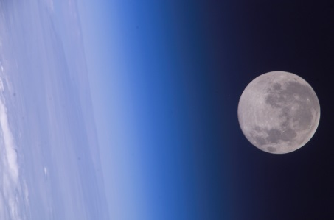
Behind the stars, hidden from view, lie unique celestial wonders. Photographed through powerful telescopes, or by orbiting satellites, these unique sights will amaze you and open your mind to our wonderful universe. Starting with the sun and moon, we will visit all the planets of our solar system.

Explore the solar system (30 minutes)
(Grades 3 through 9)
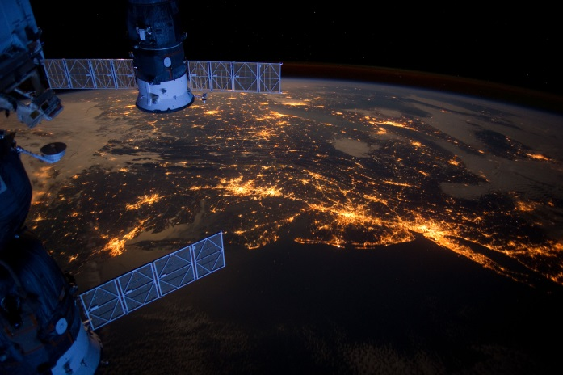
Ever wondered where the Solar System came from or how old it is? Come and find out. A brief explanation of the formation of our solar system is followed by a visit through our planetary system. Starting with the sun we will travel to all the planets, the asteroid belt, the Kuiper belt and the Oort cloud, home of the comets.

History of the Universe (30 minutes)
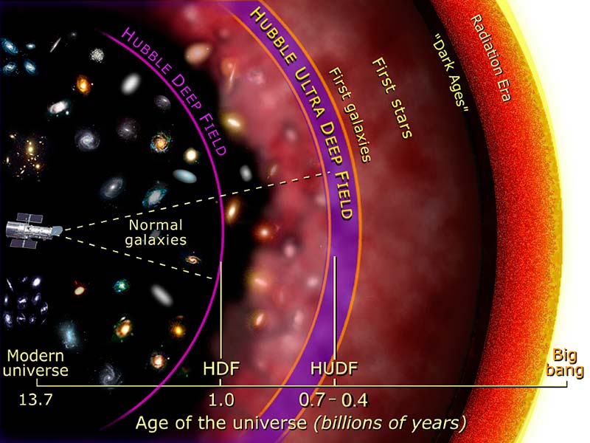
(Grades 6 through 12)

In part one of the program we saw a host of deep sky objects. They are like pieces of a puzzle in our universe. Now we will try to complete the entire picture. How did the universe begin? When did it begin? How old are the stars and galaxies? Do all the stars have planets? Will stars and our sun last forever?
Will the universe last forever?

High School astronomy

Based on Nelson’s book “Science 9”
(Grades 9 through 12)

May we suggest the following for grade 9 students?

Part 1The Sky Tonight (60 minutes for this group)

Part 2: History of the Universe (30 minutes)

Beginning with the Big Bang, we study the expansion of the universe, the lives of stars, the formation of planets and ponder the fate of the universe.

Discussion (15 minutes)

Lunch break (45 to 60 minutes)

Part 3: Formation of the Solar system (45 minutes)

See how, from a cloud of dust created by dying stars, planetary system forms. Our visit starts at the sun and we will travel through the solar system visiting all the planets, many of their moons, the asteroid belt the Kuiper belt and the Oort cloud home of the comets.

Part 4: Tools of the Astronomer (45 minutes)

Light carries a coded message, which, once deciphered, can help us determine the temperature, composition, age and motion of the stars. This presentation is accompanied by some demonstrations to explain how astronomers study stars even if they cannot get near them.

Discussion (15 minutes)

If you desire a shorter presentation, we can start with part 1 and add any component you wish.
Fathers of Astronomy: (45 minutes)
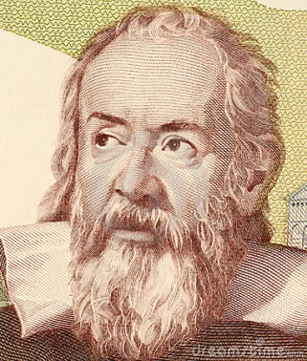

For millenniums, humans believed the Earth to be flat, stationary and the center of the universe. Five hundred years ago, Copernicus’ visionary hypothesis placed the Sun at the center of the solar system. Tyco Brahe’s observations paved the way for Kepler and his three planetary laws. Galileo was the first to use a telescope to observe the heavens. Newton later gave us the physical explanation why the sun was the center of the solar system. Come and find out the challenges and the contributions these men made to astronomy.
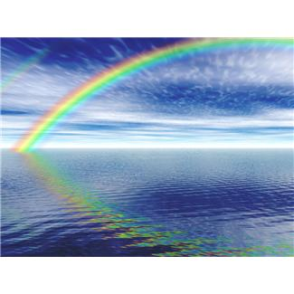

The Nature of light: (60 minutes)
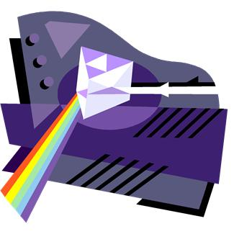

How hot is a star? What is a star made of? Do stars move? The answers are hidden in the light emitted by the star. By understanding how light is produced we can begin to decipher the message it is trying to tell us.
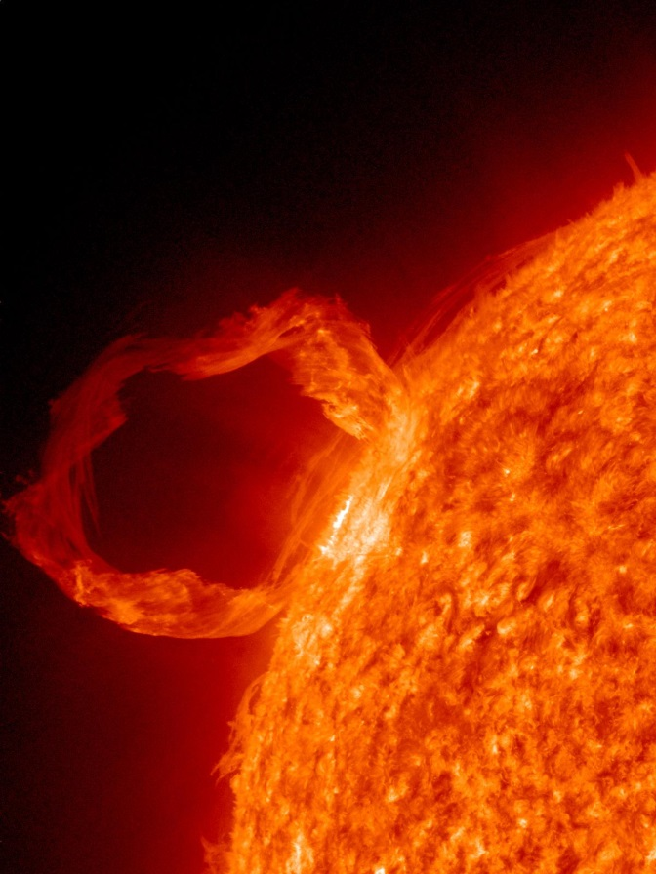
Our star: The sun (45 minutes)
For the first nine billion years in the history of the universe there was no sun. After exploring its formation we will take a close look at the structure of the sun and its power source. Find out how we can study the inside of the sun despite its ten million-degree temperature. Its surface features, granules, spicules, sun spots, flares, coronal mass ejection are spectacular to view but reveal the complexity of these tiny points of light.

Stellar Evolution: (60 minutes)
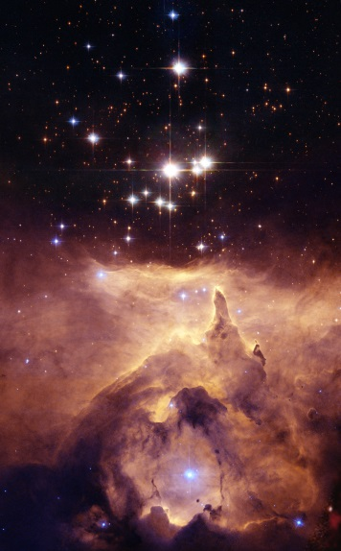

Stars have a humble beginning inside a cool, dusty nebula in a lonely region of space. After a long life as a stable star death waits to claim it’s due. As if cheating the grim reaper, the stellar corpses are among the most fascinating objects in the universe. White dwarves, neutron stars, pulsars and black holes are part of the mysterious and strange afterlife of stars.

Our cosmic cousins: (45 minutes)
As we find more planets around other stars we can help but wonder if they are inhabited. By a process of elimination we will zero in on planets that can support life, as we know it. Even if life exists, is it intelligent? Have they mastered space travel? Are UFO’s really spaceship, visiting us, from these worlds? What are the probabilities that these aliens have ever visited Earth? We will guide you but you will have to form your own opinion.

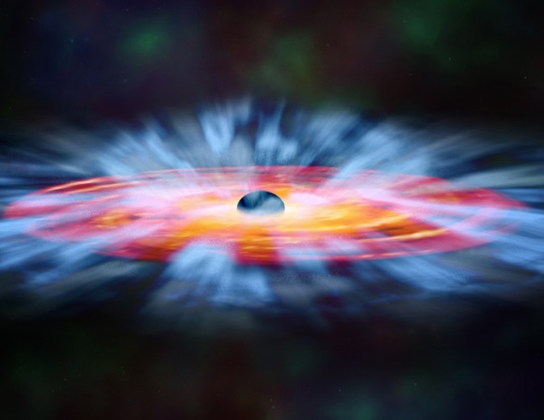
Black Holes: (60 minutes)
Nothing stirs up the imagination more than the mysterious black hole. Is it really a hole? Does it lead to another universe or to some far off corner of our galaxy? Does it travel through space like a cosmic vacuum cleaner? Its description is simple but its nature challenges our imagination. Gravity is no longer a force but an effect created by the warping of the space-time continuum.

Scale of the Universe: (60 minutes)

We live on a small planet orbiting an average star in a typical galaxy within an all-encompassing universe. How big are these objects? How far apart are they from each other? When we look at their composition we enter the world of microcosm, molecules, atoms, protons, neutrons and sub atomic particles. From infinitely small to the infinitely big is the best way to describe the building blocks of the universe.

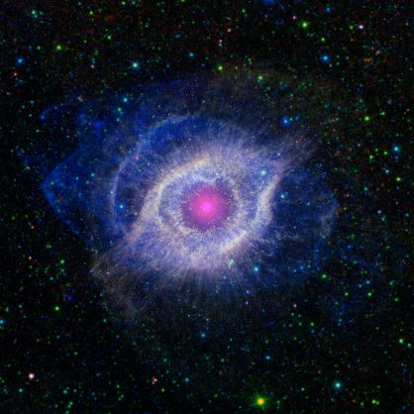
Mysterious Universe (45 minutes)
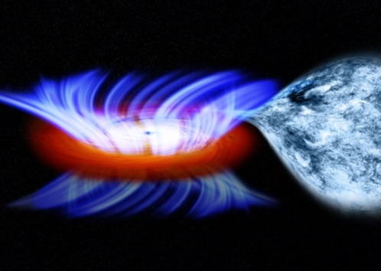
Astronomy is weirder than science fiction. Gravity is not a force but a manifestation produced by the warping of the space-time continuum. A black hole is not a hole but an infinite gravity well. Dark matter is not black; it cannot be seen and can, so far, only be detected by its gravitational effects. Looking into the depths of space is the same as looking at the past of the universe. Travelling at near the speed of light results in changes in mass dimensions and slows time of the space traveller. Weird you bet.

Formation of the solar system (45 minutes)

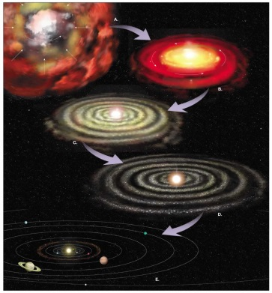

See how, from a cloud of dust created by dying stars, planetary system forms. Our visit starts at the sun and we will travel through the solar system visiting all the planets, many of their moons, the asteroid belt the Kuiper belt and the Oort cloud home of the comets.

Mars Next Stop (30 minutes)

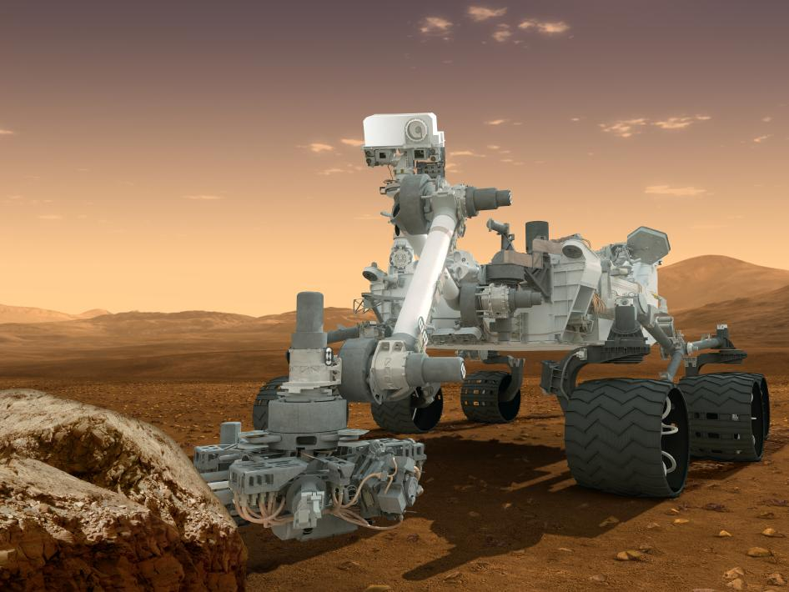

Join us on a proposed visit to Mars. How do we plan for such a trip? How will we get there? Where are we going to stay? What will we do on Mars? How will we get back?

Canada in Space (30 minutes)

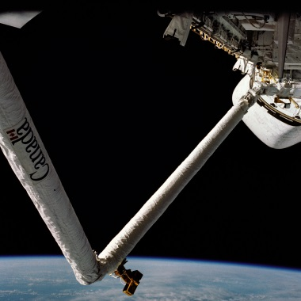
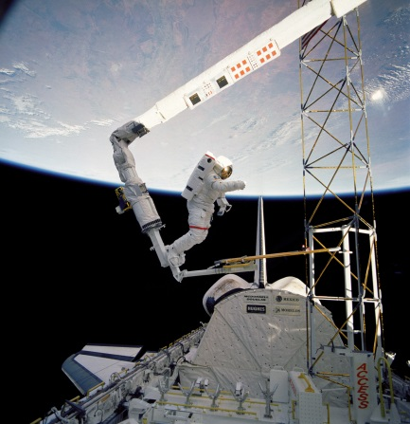
Unknown to most, Canada launched its first rocket in 1940 from Fort Churchill in Manitoba. Canada has a reputation for designing and building sophisticated satellites, not just for themselves but other countries. The Canadian Space Agency is a testimonial to our contribution in space explorations.

Astronomers Guardians of Time: (60 minutes)

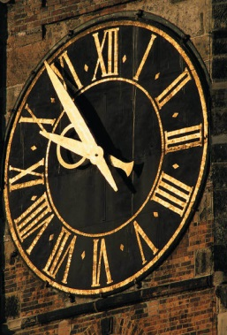

Time was for a long time measured by the motion of the sun, moon and the stars. Modern time pieces are based on these motions. From the simple gnomon and obelisk to mechanical clocks, digital watches and atomic clocks, time keeping has been the job of the astronomers.

