Organization Name | Programming Offered | Location | Contact
Mi’kmaq Friendship Centre | Multiple programs available | 2021 Brunswick St. Suite 209 | (902)-420-1576
Native Council of Nova Scotia | Multiple programs available ranging from pre-natal programs to parenting, counselling, youth programs, shelters. |  | 1-800-565-4372  www.ncns.ca
Helping all our families | Parent program, family wellness, a culturally appropriate support to Indigenous families, consulting the family to design a needs-based specialization plan. |  | Lisa.giles@mymnfc.com  (902)-420-1576
Atelhai Inuit Program | Transition support, gatherings for Inuit and their families, traditional cooking & clothing classes. |  | (902)-420-1576
Mi’kmaq Child Development Centre | Provincially funded daycare, Aboriginal head-start program, community action program for children aged 0-7. |  | (902-420-1576

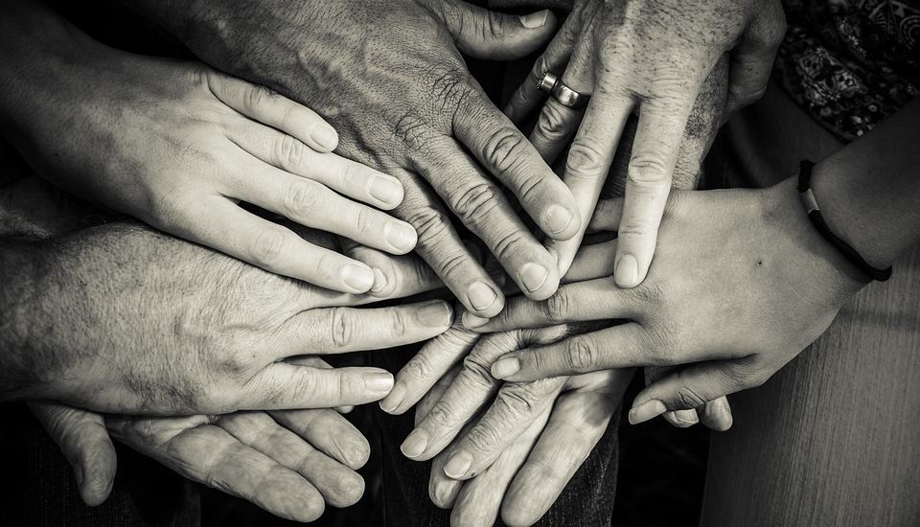

Contact us for more information
Sara Torres: Sara.Torres@Laurentian.ca
Chloe Pictou: chloebarclay123@hotmail.ca
Naiomi Metallic: naiomi.metallic@dal.ca

These materials are part of the project Knowledge mobilization focusing on protective factors for children in welfare.

Urban Indigenous, African Nova Scotian, and immigrant and refugee communities are overrepresented in the child welfare system. Having supports and resources available to these communities is essential to strengthening and keeping families together. You can find a full list of supports at strongcommunities.laurentian.ca.

