Organization Name | Programming Offered | Location | Contact
Afghan Society of Halifax | Children’s programming, cultural events, supporting the 265 Afghan newcomers that arrived to Halifax in December, 2021 | 21 Inspector Ct., Halifax | 902-406-0404  afghansocietyofhalifax.ns@gmail.com
African Diaspora Association of the Maritimes | Food bank, community connections. | 2625 Joseph Howe Drive, Halifax | info@africandiasporaassociationof-themartitimes.ca
Bayers/Westwood Family Support Services | Drop-in activities, family support, language programs | 3499 McAlpine Ave, Halifax | (902) 454-9444
Canadian Lebanon Society of Halifax | Networking, social events, etc. | 255 Bedford Hwy, Halifax | 902-444-4257  info@canadianlebanonsociety.ca
Chebucto Family Centre | Parenting support, child programs, etc. | 3 Sylvia Av, Halifax | (902) 479-3031
Generation 1 Leadership Initiative | Youth leadership opportunities, STEAM education, cultural awareness | n/a | generation1leadership@gmail.com
Immigration Services Association of Nova Scotia (ISANS) | Settlement services, parenting programs, career support | 6960 Mumford Rd Suite 2120, Halifax | (902) 423-3607  Toll free in Nova Scotia: 1-866-431-6472
Korean Association of Halifax | Networking, exploring job opportunities, making connections, forum, etc. | 6249 Quinpool Rd, Halifax | representative.korean.of.ns@gmail.com
Latispanica | Cultural events, networking. | n/a | info@latispanica.org
Nova Scotia Islamic Community Centre | Different camps, recreational activities, etc. | 2143 Larry Uteck Blvd., Bedford | 902-832-6300  info@nsicc.ca
Pakistani Canadian Association of Nova Scotia | Cultural events, settlement services, music and recreational programs. | Purdy's Wharf Tower 1100-1959 Upper Water Street, Halifax, NS B3J 3N2 | info@pcans.ca  www.pcans.ca
Ummah Masjid and Community Centre | Youth counselling, family counselling, camps, recreational activities, explore employment opportunities, etc. | 2510 St. Matthias St., Halifax | 902-407-1411  info@umcc.ca
Veith House | Children’s programming, parenting classes, urban community garden, etc. | 3115 Veith St, Halifax | 902-453-4320

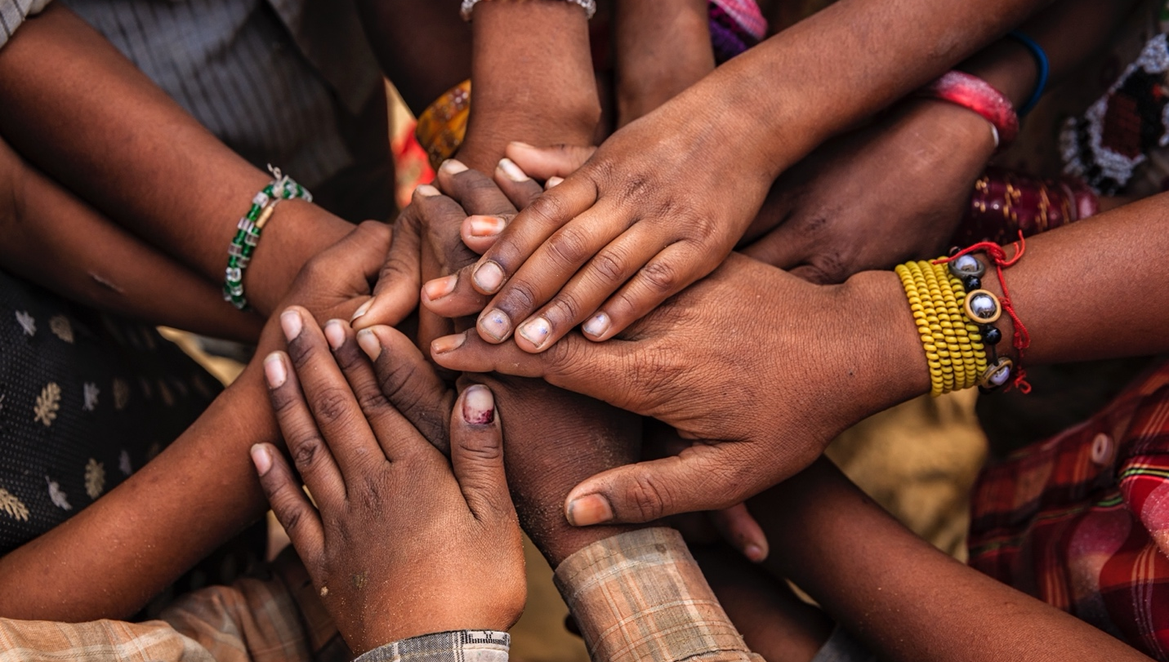

Contact us for more information
Sara Torres: Sara.Torres@Laurentian.ca
Stephanie Barron: stephanie.barron@dal.ca

These materials are part of the project Knowledge mobilization focusing on protective factors for children in welfare

Immigrant and refugee, African Nova Scotian, and urban Indigenous communities are overrepresented in the child welfare system. Having supports and resources available to these communities is essential to strengthening and keeping families together. You can find a full list of supports at strongcommunities.laurentian.ca.

