Organization Name | Programming Offered | Location | Contact
African Diaspora Association of the Maritimes (ADAM) | Supports for African people who move to Nova Scotia | 200 Kempt Rd #202, Halifax, NS B3K 4X1 | (902) 404-3670
African Nova Scotian Affairs | Multiple programs; supports projects and activities that bring ANS together to network and share ideas | 3rd Floor, 1741 Brunswick St, Halifax, NS B3J 3X8 | (902) 424-5555
Caring and Learning Centre | Programs and services aimed at strengthening families and building strong bonds within the community | 57 Jarvis Lane, Halifax,  NS B3K 3J3 | (902) 453- 5089  caring.learning@mulgravepark.ca
Family SOS | Child-centered organization that offers multiple programs and services toward building strong and healthy families | 2006 Gottingen St.  Halifax, NS B3K 3B1 | (902) 455 5515  info@familysos.ca
YMCA –Immigrant services | Variety of programs and outreach services | 104-7071 Bayers Road Halifax, NS B3L 2C2 | (902) 457 9622
Dartmouth Family Centre  Dartmouth, NS | Multiple programs and services to families that promotes healthy living | 107 Albro Lake Rd, Dartmouth, NS B3A 3Y7 | (902) 464-8234
North Preston Daycare | Child Care Centre that offers daycare for infants, toddlers, kindergarten, and preschoolers | 52 Cain St, North Preston, NS B2Z 1A2 | (902) 453-5008  npdaycare@eastlink.ca
NS Brotherhood Initiative | Educational workshops and health clinics, with a focus on the health needs of African N.S. men | 260 Wyse Road, Dartmouth | Colin Campbell: Colin.Campbell@nshealth.ca  Tel: 902-434-0824  nsbrotherhood@cdha.nshealth.ca
Upper Hammonds Plains Community Centre | Facility that hosts various events | 711 Pockwock Road, Upper Hammonds Plains | n/a
North Preston Community Centre | Multi-purpose facility that offers programs and hosts multiple community event | 44 Simmonds Rd, North Preston, NS B2Z 1A3 | (902) 434 3807
East Preston daycare/family resource centre | Unique and useful programs, groups, workshops and events for children, youth and children. | 1900 Highway 7  East Preston, NS  B2Z 1M2 | Family resource centre: 902–462–7266  Daycare: 902–462–0054
Association of Black Social Workers | Educational and community based programs, ranging from clinical counselling to professional development. | 1018 Main St, Dartmouth, NS B2W 4X9  (902) 407-8809 | Veronica Marsman: vmarsman@me.com
North Preston Health and Wellness Centre | Provides health care and wellness programming | 44 Simmonds Road, North Preston  Nova Scotia, B2Z 1A3 | 902-434-3809
Black Educators Association | Multiple services, supports and educational programs; provides educational bursaries/scholarships to students. | 2136 Gottingen Street, Halifax  Nova Scotia, B3K 3B3 | 902-424-7036
Mulgrave Park Family Resource Centre (Parenting Journey) | Safe, supportive and friendly programs and services that help families build strong bonds within the community; resource center | 57 Jarvis Lane, Halifax  Nova Scotia, B3K 3J3 | 902-453-5089

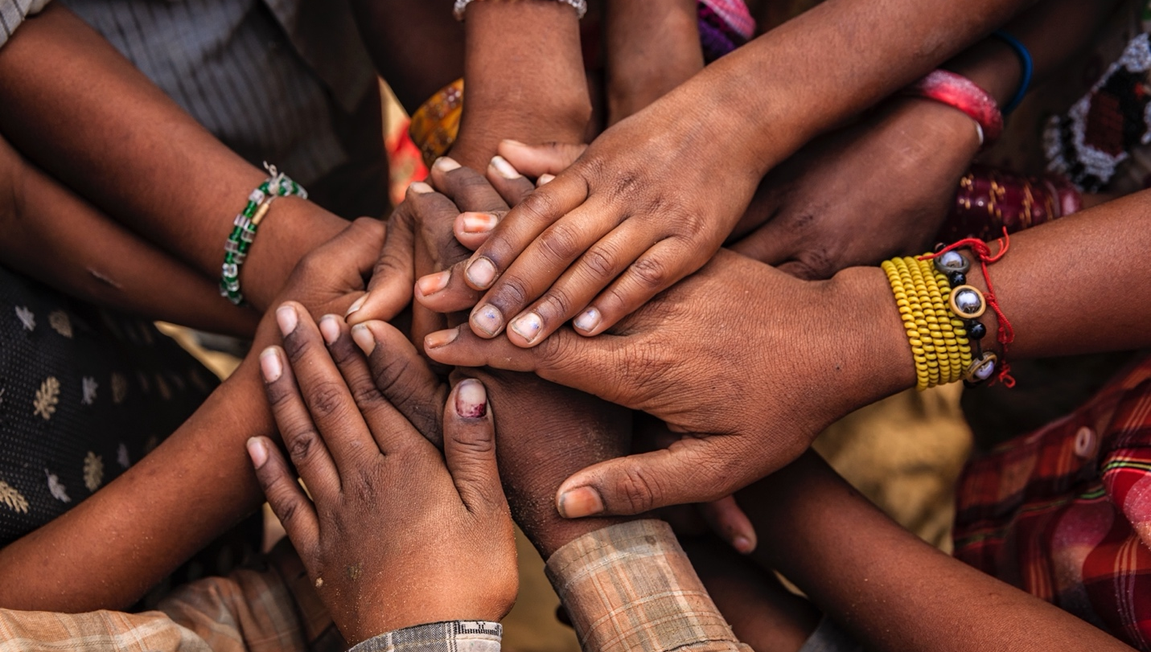

Contact us for more information
Sara Torres: Sara.Torres@Laurentian.ca
Marsha Hudson Ash: marshaha@bellaliant.net

These materials are part of the project Knowledge mobilization focusing on protective factors for children in welfare

African Nova Scotian, urban Indigenous, and immigrant and refugee communities are overrepresented in the child welfare system. Having supports and resources available to these communities is essential to strengthening and keeping families together. You can find a full list of supports at strongcommunities.laurentian.ca.

